D-311 Unit 5: Initial Attack Dispatch Environment / WildCAD-E Intro

Summary:
This unit will focus on how the IADP should prepare for working in the dispatch environment, how to manage stress and overview of the WildCAD-E computer application.

Objectives:
- Identify three unique elements that the IADP should receive from a briefing.
- Identify and discuss common situations that create stress in a busy dispatch environment.
- Describe four techniques that are effective in responding to urgent/stressful situations.
- Utilize WildCAD-E to map, create and maintain and incident(s).

Unit at a Glance:
Topics | Method | Duration
Unit Overview | Presentation | 5 Minutes
The Dispatch Environment | Presentation  and Group Discussion | 30 Minutes
WildCAD- E Intro | Presentation, Group Discussion & Exercises | 2 Hours 30 Minutes
Activity Fires Tab | Presentation | 15 Minutes
Knowledge Check | Group Activity | 10 Minutes
Total Unit Duration |  | Total 3 hours 30 mins

Preparation:
Review PowerPoint, handouts and instructor guide, make notes on how to guide students through class discussions.

Course Materials:
Exercise 1 Handout – 1 per student
Exercise 2 Handout – 1 per student
Exercise 3 Handout – 1 per student

Classroom:
- Ability to display images and video on large screen.
- Computers to access WildCAD-E Training Program.

Key

Headings with icons:
Review

Handout

Reference Standard

Group Discussion

Play Video

Activity

Title Slide
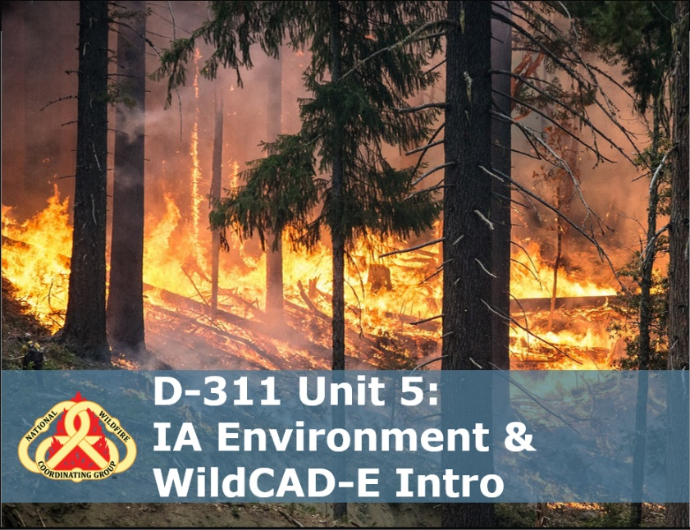

Unit Overview
Unit Overview
Summarize how this unit will focus on how IADPs prepare for working in the dispatch environment, how to manage stress and overview of the WildCAD-E computer application. WildCAD-E section will give students and overview of the program, menus, how to map, create and maintain incident information.
The traveling IADP who has been dispatched to an assignment carries a skill set developed through prior formal training, informal/on-the-job training, and prerequisite experience.

DISCUSSION
- What can you do to ensure that you will be fully successful in your assignment?
  - Stop
  - Breathe
  - Take Stock
  - Ask Questions
  - Get Information

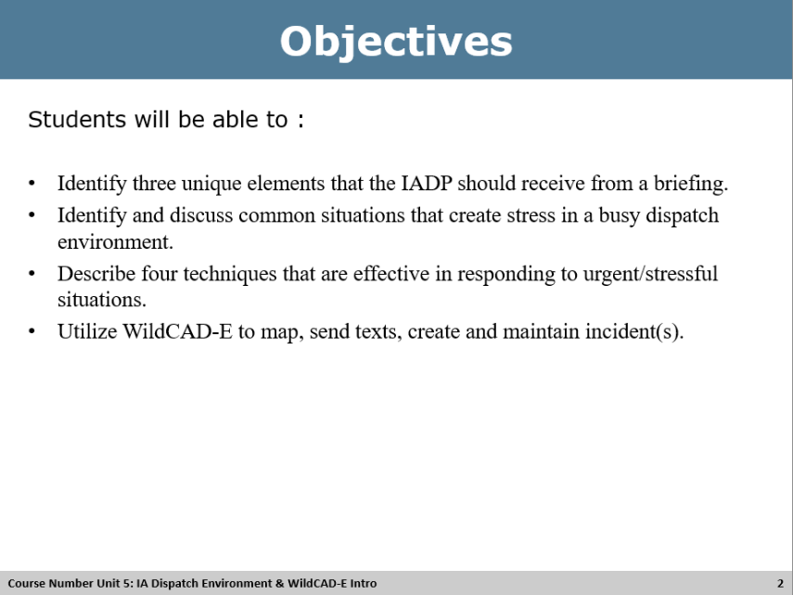

Unit Objectives
Review Unit Objectives
DO: Refer the participants to the objectives as listed in the PowerPoint slide. Allow time for the participants to review.

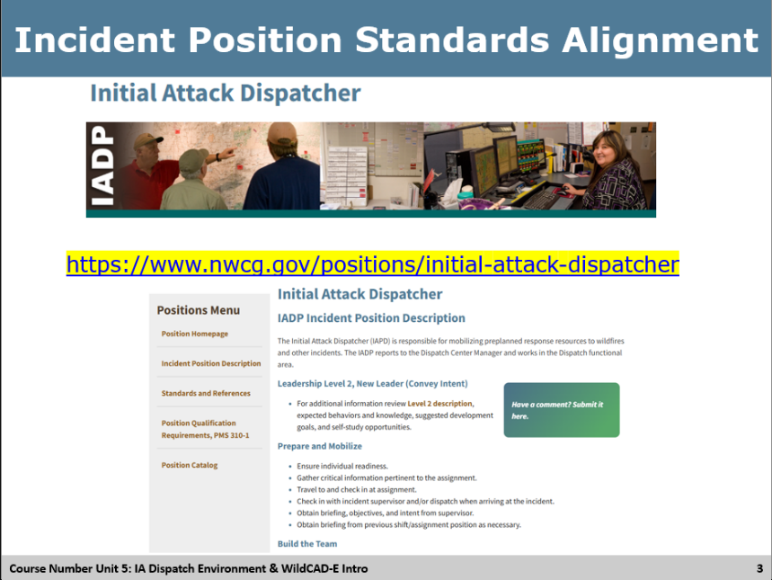

Incident Position Standards
Review Incident Position Standards Alignment
DO: Refer to the Incident Position Standards Alignment slide and allow participants a moment to review their copy of the Incident Position Standards document, specifically the Table of Contents, as it relates to the Unit’s topic.
ASK: What responsibilities statements might align with preparing for an assignment?
Answer: Listen for responses like
  - Resource Order
  - Building a kit
  - Ensuring access to dispatch programs – FireNet, IROC, WildCAD-E
  - Credit card and travel booked
  - Others?

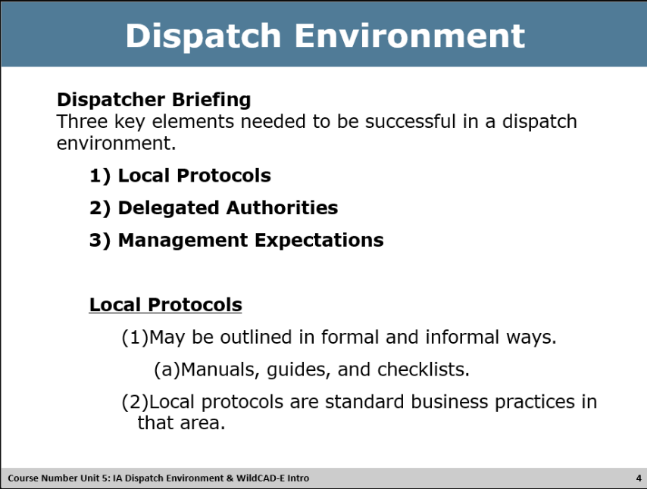

Local Protocols
Review Local Protocols
DO: Refer to the PowerPoint slide to explain the three Key elements to a Dispatcher briefing – Local Protocols.
The 3 Key Elements:
- Local Protocols
- Delegated Authorities
- Management Expectations
Each element has a dedicated slide.

Group Discussion
DO: Discuss what references you could use to find what the local protocols are.
ASK: What references could you use to find out what the local protocols are?
Answers: (List some examples if the class is unable)
- Manuals – Departmental manuals, Interagency Standards for Fire and Fire Aviation Operations (Red Book), etc.
- Guides – National Interagency Standards for Resource Mobilization (NISRM), etc.
- Checklists – IA Checklist, Daily Duties, Intel Checklist, etc.
- Standard operating procedures (SOPs) – SharePoint, Binder, Folders, etc.
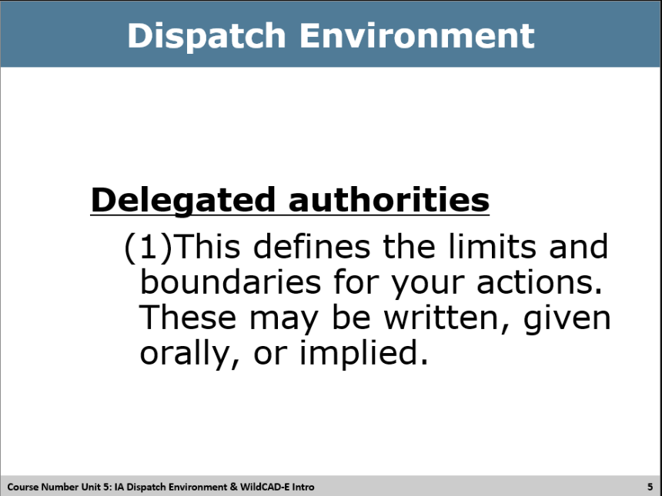

Delegated Authorities
Review Delegated Authorities
DO: Refer to the PowerPoint slide to explain the Key elements to a Dispatcher briefing – Delegated Authorities

Group Discussion
DO: Discuss what delegated authorities you want to review and understand as dispatcher.
ASK: What authorities do you have and need defined and what questions should you ask during your briefing?
Answers:
- Can you assign resources based on your best judgement?
- Do you follow run cards?
- Do you ask the FMO/Duty Officer?
- Can you dispatch air tankers, helicopters, air attack?
- Can you spend money for food or/and lodging?
- Can you bump up resources?
- Others?

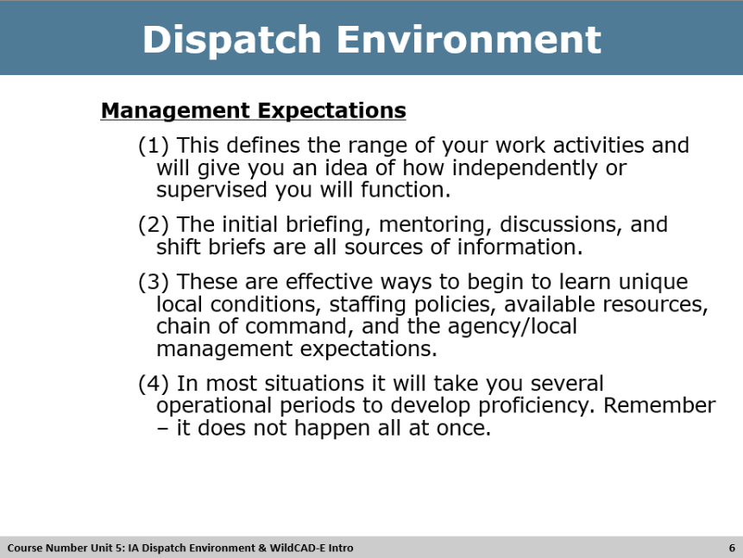

Management Expectations
Review Management Expectations
DO: Refer to the PowerPoint slide to explain the Key elements to a Dispatcher briefing – Management Authorities.

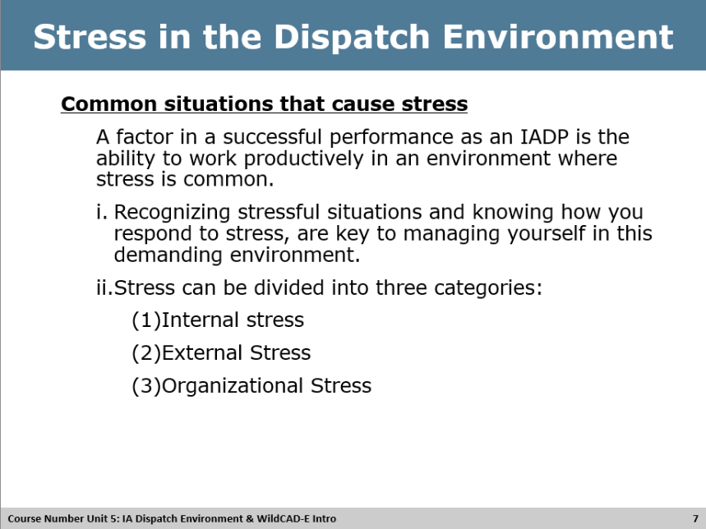

Stress in the Dispatch Environment – Internal
Review Stress in the Dispatch Environment
DO: Refer to the PowerPoint slide to explain the common situations that cause stress and how we are responsible to manage ourselves, which manages stress.

Review the three categories of stress listed on slide.

Group Discussion
DO: Discuss internal stressors and how this is something you may be able to personally mitigate.
ASK: What do you think are some internal stressors (yourself)?
Answers:
- Exhaustion/poor sleep habits
- Co-Worker interaction
- Personal situations
- Poor eating habits’
- Others?

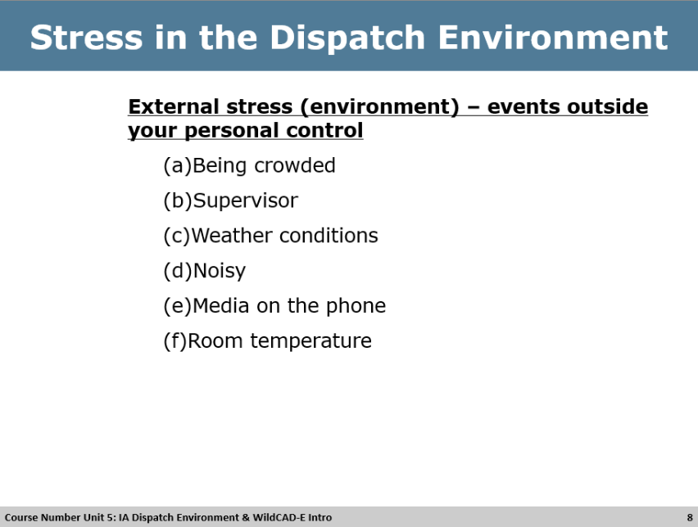

Stress in the Dispatch Environment – External
Review Stress in the Dispatch Environment – External Stress
DO: Refer to the PowerPoint slide to explain the common situations that cause stress outside of your personal control and how we are responsible to manage ourselves, which helps manage stress.

Discuss the eternal stress factors listed on the slide and ask class for other examples not listed.

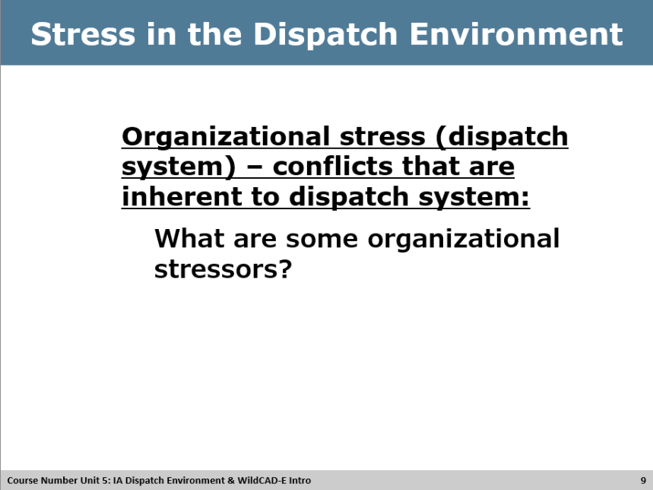

Stress in the Dispatch Environment - Organizational
Review Stress in the Dispatch Environment – Organizational Stress
DO: Refer to the PowerPoint slide to explain the common situations that cause stress and how we are responsible to manage ourselves, which manages stress.

Group Discussion
DO: Discuss organizational stressors and how can you mitigate.
ASK: What do you think are some organizational stressors (dispatch system)? How can these be mitigated?
Answers:
- Multiple tasks that need to be done at the same time.
- Established dispatch ordering procedures
- Chain of command
- Authorities and regulations
- Multiple incidents
- Staffing shortages
- Others?

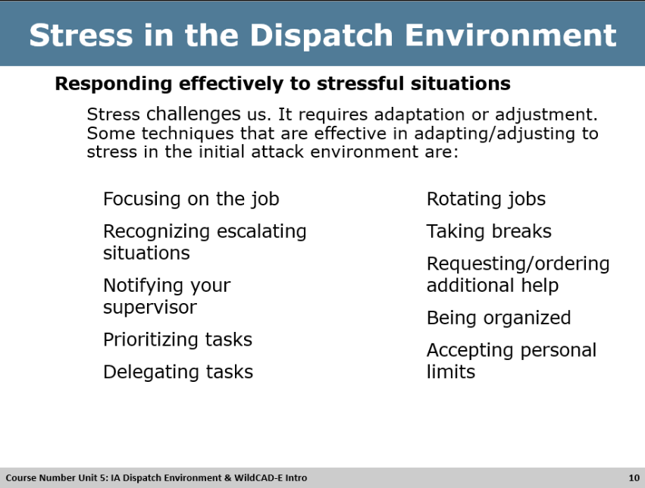

Responding Effectively to Stress
Review Responding effectively to stressful situations
DO: Refer to the PowerPoint slide to discuss ways to effectively respond to stressful situations.

Discuss effective ways dispatchers can respond to stressful situations listed on the slide and see if the class has other suggestions.

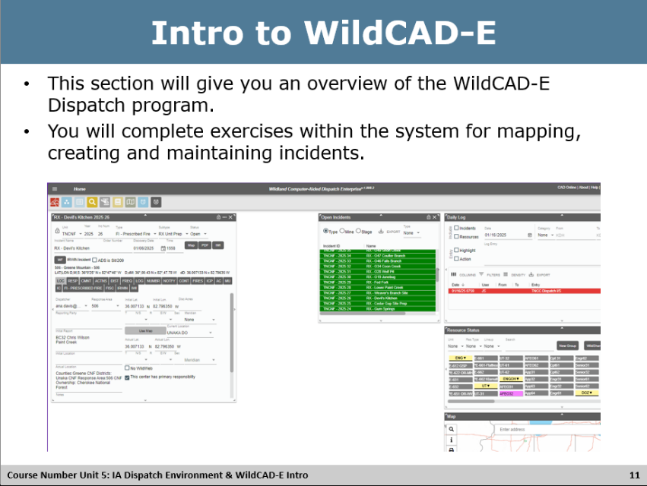

Intro to WildCAD -E - Overview
Review Intro to WildCAD- E
DO: Refer to the PowerPoint slide to discuss the overview of WildCAD-E.

Discuss this section will contain a brief overview of the WildCAD-E menus and then will complete exercises utilizing the program for mapping and incident creation.

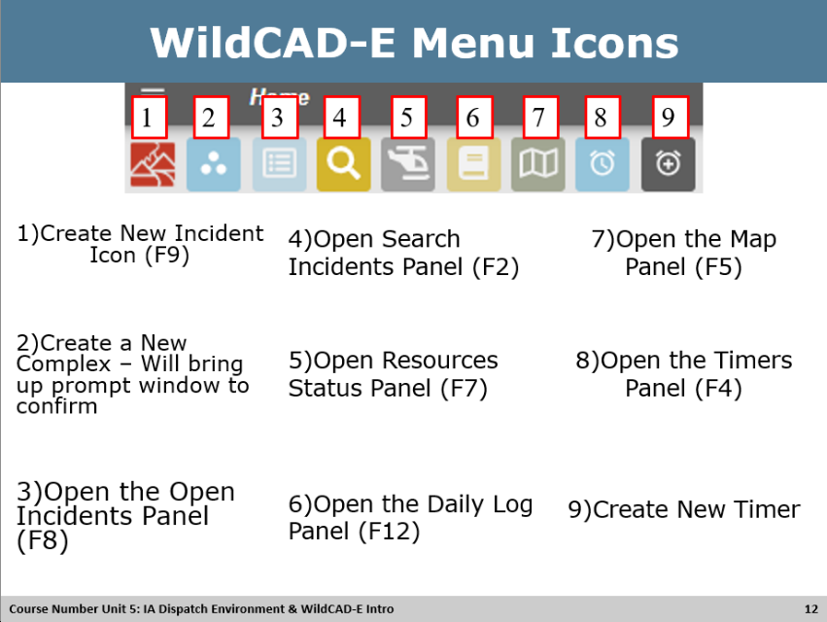

Intro to WildCAD -E – Menu Icons
Review WildCAD- E Menu icons
DO: Refer to the PowerPoint slide to discuss the overview of WildCAD-E menu icons.

Discuss each icon and the functionality of the icon. Can have students follow along within their CAD training platform, instructor discretion. Make sure to note a window will pop-up a description when you hover over the icon in WildCAD-E.

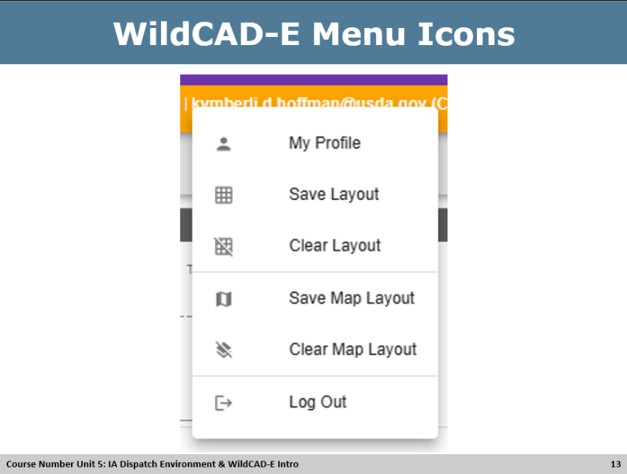

Intro to WildCAD -E – Main Menus Icons
Review WildCAD- E Menu main menu icons
DO: Refer to the PowerPoint slide to discuss the overview of WildCAD-E main menu icons.

Discuss and describe the functionality of each menu item. Can have students follow along within their CAD training platform, instructor discretion.

Instructor: Go over Saving Layouts (Screen and Map) and have them save layout with Map Panel, Daily Log, Resources panel, Open Incidents Panel.

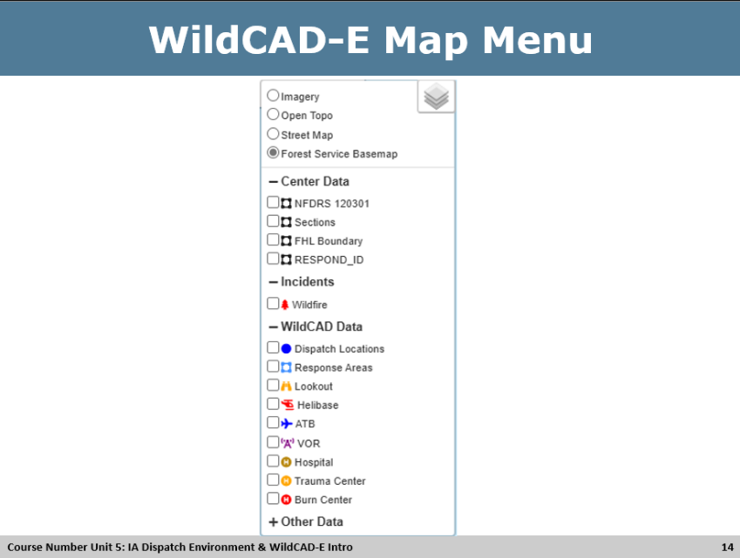

Intro to WildCAD -E – Map Menus Icons
Review WildCAD- E Map menu icons
DO: Refer to the PowerPoint slide to discuss the overview of WildCAD-E map menu icons.

Discuss and describe the functionality of each menu item. Can have students follow along within their CAD training platform, instructor discretion.

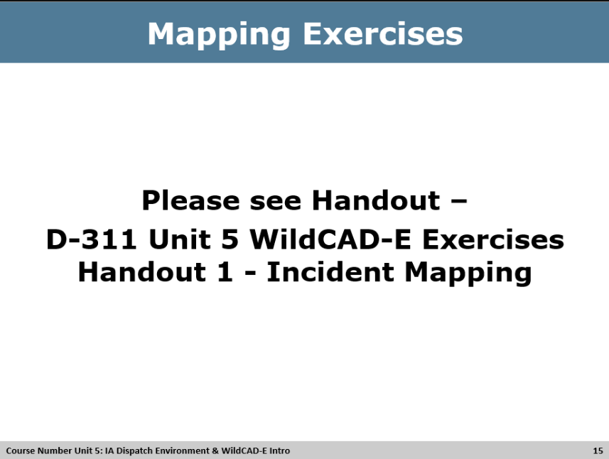

Activity – Handout 1
Activity
<WildCAD-E Mapping exercises>
Materials: Handout, 1 for each student. File Name D-311 Unit 5 WildCAD-E Exercises Handout 1 - Incident Mapping, WildCAD-E Training platform.
Length: 30 min. (5 min. launching map overview, 15 min. activity, 10 min. debrief)
Purpose: The purpose of this activity is to provide students the opportunity to use the WildCAD-E program to utilize the mapping functionality.
Directions: Each student should get Handout 1, and the activity provides an overview of the mapping functionality in WildCAD-E and walks them through mapping exercises, utilizing the individual WILDCAD-E training platform to perform the exercises. Can be done individually or as a group, instructor discretion. The last exercise named Student name – C will set them up for the next exercise.
Instructor: Walk student through the functionality of the map FIND panel and what the different fields mean and how they function. Review information found in the map footer; remind students that custom layers will be different for each center. Make sure to discuss the on the Forest Service Basemap Layer that you can usually zoom out to see county boundary lines, not all centers have a custom county layer that shows in map footer.
Activity Debrief Questions: Review the answer key at the end, to ensure that the students arrived at the correct answer.
Coach Directions: The coaches can assist students during the exercises to steer them in the correct direction, utilizing the Handout 1 - Answer Key.
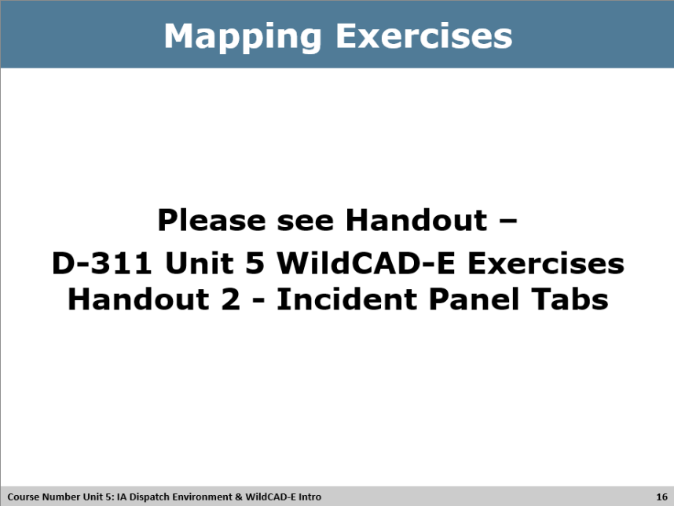

Activity – Handout 2
Activity
<WildCAD-E Incident Panel exercises>
Materials: Handout, 1 for each student. File Name D-311 Unit 5 WildCAD-E Exercises Handout 2 - Incident Panel Tabs, WildCAD-E Training platform.
Length: 1 hour. (10 min. incident panel overview, 40 min. activity, 10 min. debrief)
Purpose: The purpose of this activity is to provide students the opportunity to use the WildCAD-E program to become familiar with the incident panel and tab functionality. They will create and maintain an incident from start to finish, filling out tabs most frequently used by dispatch centers.
Directions: Each student should get Handout 2, and the activity provides an overview of the incident panel functionality in WildCAD-E and walks them through incident panel exercises, utilizing the individual WILDCAD-E training platform to perform the exercises. Should be done individually. The incident created in last exercise named Student name – C will be utilized.
Instructor:
Review the incident panel tabs, definitions and functionality before having students perform the exercise. Students can follow along in their CAD training platform by opening an incident they created.
Incident Header, LOC (Location tab), RESP (Response tab), CMNT (Comments tab), ACTNS (Actions tab), DIST (Distance tab), FREQ (Frequency Tab), LOG (Incident Log tab), NUMBR (Numbers tab), NOTFY (Notifications tab), CONT (Contract tab), FIRES (Fire Information tab), ICP (Incident Command Post tab), AC (Aircraft tab), MU (Move up tab), IC (Incident Commander Tab), Questions tab – takes the name of the Incident type, FISC (Fiscal Codes tab), IRWIN (IRWIN Information tab), CONF (Incident Conflict tab), IWI (Incident within an Incident tab).
Activity Debrief Questions: Review the answer key at the end, to ensure that the students arrived at the correct answer.
Coach Directions: The coaches can assist students during the exercises to steer them in the correct direction, utilizing the Handout 2 - Answer Key.

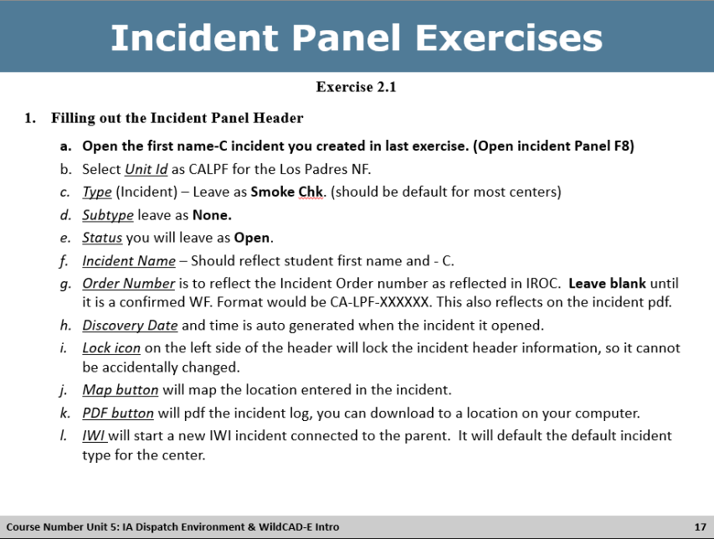

Activity – Exercise 2.1 Incident Panel Header
Activity
Materials: Utilize Information on slide, handout and WildCAD-E Training platform.
Length: 10 min. (5 min. review slide and Incident Panel header, 5 min. activity)
Purpose: The purpose of this activity is to provide students the opportunity to use the WildCAD-E program to learn and utilize fields in the incident panel header.
Directions: Each student should review information for incident header on the slide/handout for incidents in WildCAD-E utilizing the individual WILDCAD-E training platform to perform the exercises. Should done individually. The last exercise named Student name – C will be the incident used for the activity.
Instructor: Explain the different fields in the incident panel header and the functionality. Have students use information in Handout 2, exercise 2.1 to fill out the header information in Incident C.
Activity Debrief Questions: Review the answers at the end, to ensure that the students arrived at the correct answer. Instructor and Coaches should review with answer key.

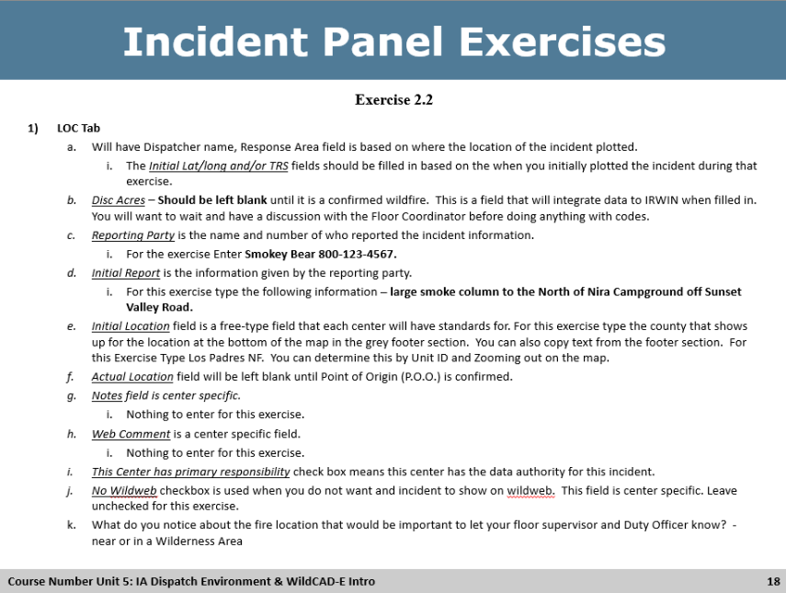

Activity – Exercise 2.2 Location (LOC) Tab
Activity
Materials: Utilize Information on slide, handout and WildCAD-E Training platform.
Length: 10 min. (5 min. review slide and Incident Panel LOC Tab, 5 min. activity)
Purpose: The purpose of this activity is to provide students the opportunity to use the WildCAD-E program to learn and utilize fields in the incident location tab.
Directions: Each student should review information for incident panel Location tab on the slide/handout for incidents in WildCAD-E utilizing the individual WILDCAD-E training platform to perform the exercises. Should done individually. The last exercise named Student name – C will be the incident used for the activity.
Instructor: Explain the different fields in the Incident panel Location (LOC) tab and the functionality. Have students use information in Handout 2, exercise 2.2 to fill out the information in Incident C.
Activity Debrief Questions: Review the answers at the end, to ensure that the students arrived at the correct answer. Instructor and Coaches should review with answer key.

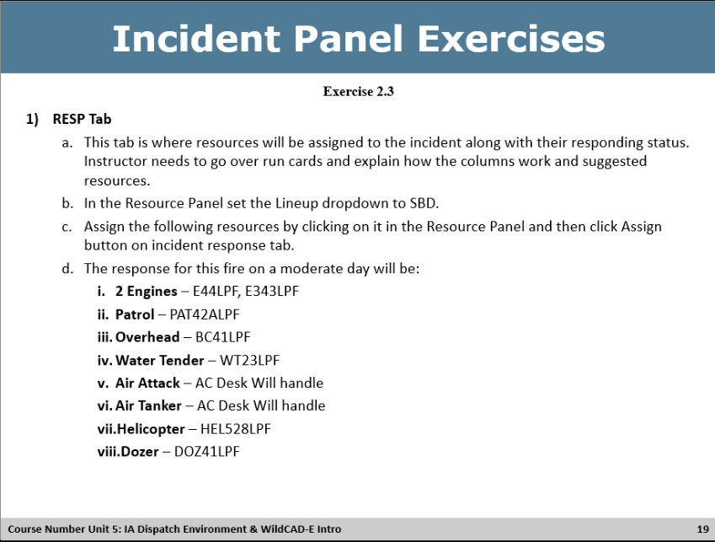

Activity – Exercise 2.3 Response (RESP) Tab
Activity
Materials: Utilize Information on slide, handout and WildCAD-E Training platform.
Length: 10 min. (5 min. review slide and Incident Panel RESP Tab, 5 min. activity)
Purpose: The purpose of this activity is to provide students the opportunity to use the WildCAD-E program to learn and utilize fields in the incident response tab.
Directions: Each student should review information for incident panel Response tab on the slide/handout for incidents in WildCAD-E utilizing the individual WILDCAD-E training platform to perform the exercises. Should done individually. The last exercise named Student name – C will be the incident used for the activity.
Instructor: Explain the different fields in the incident panel Response (RESP) tab and the functionality. Have students use information in Handout 2, exercise 2.3 to fill out the information in Incident C.
Make sure to explain the LINEUP drop down in the Resource Status panel. Not all centers may have this functionality. Highlight the Comment line on the response tab and how anything typed in there is auto logged over to the incident log tab. Sequence is select resource, type comment, select status.
Activity Debrief Questions: Review the answers at the end, to ensure that the students arrived at the correct answer. Instructor and Coaches should review with answer key.

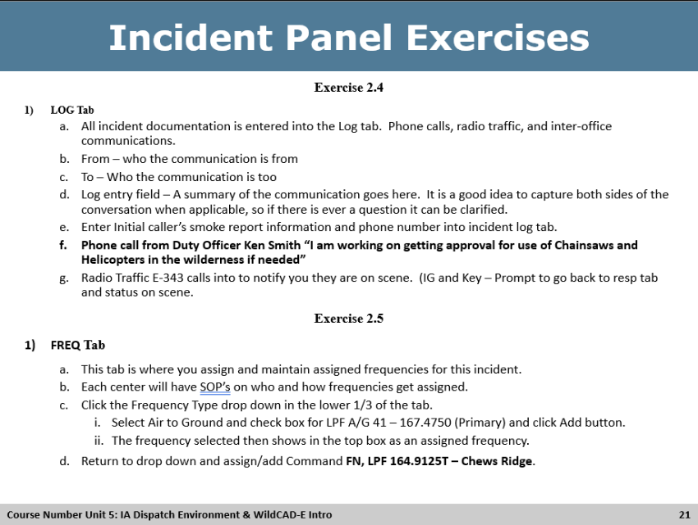

Activity – Exercise 2.4 & 2.5 Log Tab & Frequency (FREQ) Tab
Activity
Materials: Utilize Information on slide, handout and WildCAD-E Training platform.
Length: 10 min. (5 min. review slide and incident panel Log and FREQ Tab, 5 min. activity)
Purpose: The purpose of this activity is to provide students the opportunity to use the WildCAD-E program to learn and utilize fields in the incident Log and Frequency (FREQ) tabs.
Directions: Each student should review information for incident Log and Frequency (FREQ) tabs on the slide/handout for incidents in WildCAD-E utilizing the individual WILDCAD-E training platform to perform the exercises. Should done individually. The last exercise named Student name – C will be the incident used for the activity.
Instructor: Explain the different fields in the incident Log and Frequency (FREQ) and the functionality. Have students use information in Handout 2, exercise 2.4 & 2.5 to fill out the information in Incident C.
Activity Debrief Questions: Review the answers at the end, to ensure that the students arrived at the correct answer. Instructor and Coaches should review with answer key.

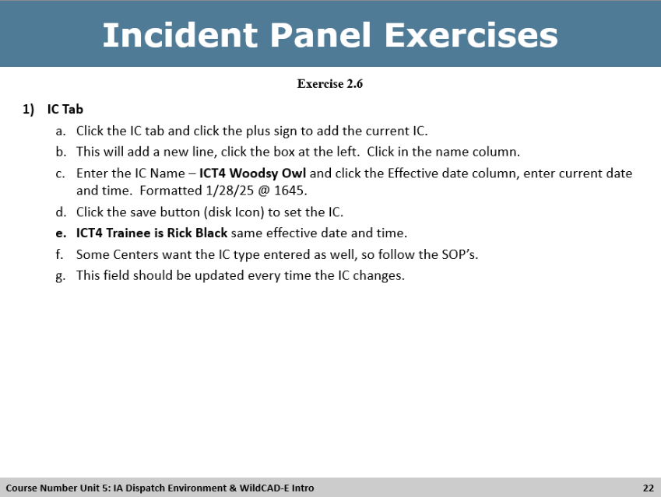

Activity – Exercise 2.6 IC Tab
Activity
Materials: Utilize Information on slide, handout and WildCAD-E Training platform.
Length: 5 min. (5 min. review slide and IC Tab activity)
Purpose: The purpose of this activity is to provide students the opportunity to use the WildCAD-E program to learn and utilize fields in the incident IC tab.
Directions: Each student should review information for incident IC Tab on the slide/handout for incidents in WildCAD-E utilizing the individual WILDCAD-E training platform to perform the exercises. Should done individually. The last exercise named Student name – C will be the incident used for the activity.
Instructor: Explain the different fields in the incident IC Tab and the functionality. Have students use information in Handout 2, exercise 2.6 to fill out the information in Incident C.
Activity Debrief Questions: Review the answers at the end, to ensure that the students arrived at the correct answer. Instructor and Coaches should review with answer key.

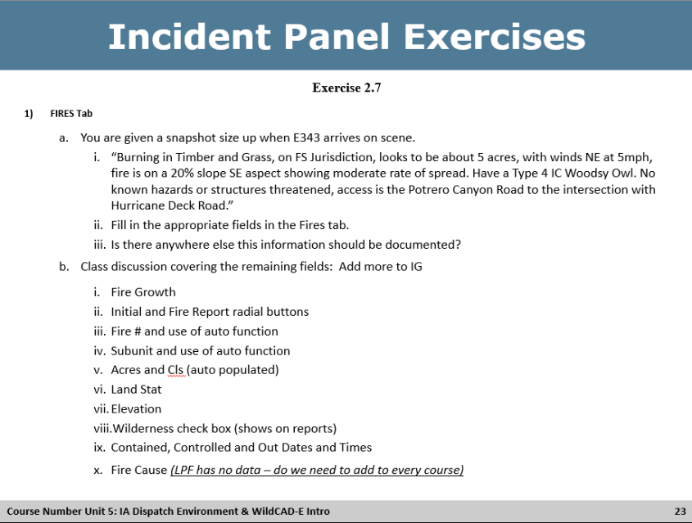

Activity – Exercise 2.7 FIRES Tab
Activity
Materials: Utilize Information on slide, handout and WildCAD-E Training platform.
Length: 10 min. (5 min. review slide and FIRES Tab, 5 min activity)
Purpose: The purpose of this activity is to provide students the opportunity to use the WildCAD-E program to learn and utilize fields in the incident FIRES tab.
Directions: Each student should review information for incident FIRES Tab on the slide/handout for incidents in WildCAD-E utilizing the individual WILDCAD-E training platform to perform the exercises. Should done individually. The last exercise named Student name – C will be the incident used for the activity.
Instructor: Explain the different fields in the incident FIRES Tab and the functionality. Have students use information in Handout 2, exercise 2.7 to fill out the information in Incident C.
Students should type size up in LOG and add information to the correct fields in the fires tab.
Discuss the elements that feed through IRWIN and the functionality of all the fields.
    - Fire Growth
    - Initial and Fire Report radial buttons –cover these fields so that they are prepared for centers that utilize them for Full Size-ups and Fire Report information. LPF has a limited example, since it is the same info as above in the tab. Other Centers have full size up Card and Information for Final Fire Report. Emphasize they need to review and follow center SOP’s.
    - Fire # and use of auto function
    - Subunit and use of auto function
    - Acres and Cls
    - Land Stat
    - Elevation
    - Wilderness check box (shows on reports)
    - Contained, Controlled and Out Dates and Times
    - Fire Cause (LPF has no data – do we need to add to every course)
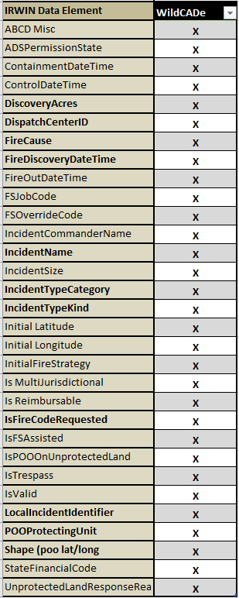
  - WildCAD-E IRWIN fed fields (31 fields)

Activity Debrief Questions: Review the answers at the end, to ensure that the students arrived at the correct answer. Instructor and Coaches should review with answer key.
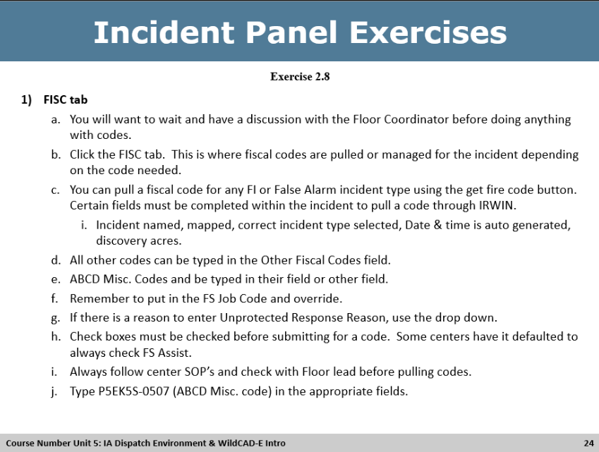

Activity – Exercise 2.8 Fiscal (FISC) Tab
Activity
Materials: Utilize Information on slide, handout and WildCAD-E Training platform.
Length: 5 min. (5 min. review slide and FISC Tab activity)
Purpose: The purpose of this activity is to provide students the opportunity to use the WildCAD-E program to learn and utilize fields in the Fiscal (FISC) tab.
Directions: Each student should review information for incident FISC Tab on the slide/handout for incidents in WildCAD-E utilizing the individual WILDCAD-E training platform to perform the exercises. Should done individually. The last exercise named Student name – C will be the incident used for the activity.
Instructor: Explain the different fields in the incident FISC Tab and the functionality. Have students use information in Handout 2, exercise 2.6 to fill out the information in Incident C.
Activity Debrief Questions: Review the answers at the end, to ensure that the students arrived at the correct answer.
Instructor and Coaches should review with answer key.

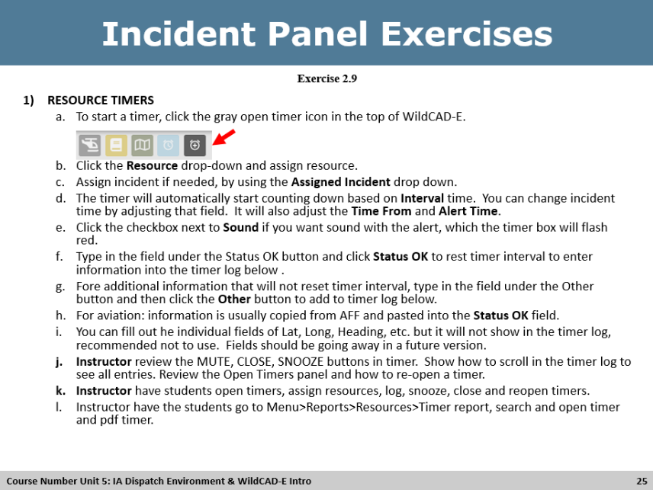

Exercise 2.9 Exercise - Timers
Activity
Materials: Utilize Information on slide, handout and WildCAD-E Training platform.
Length: 20 min. (10 min. review slide/handout & 10 minutes to perform exercise)
Purpose: The purpose of this activity is to provide students the opportunity to use the WildCAD-E program to learn and utilize fields in the system to open, maintain, close and view a resource timer.
Directions: Students should be able to independently create, enter and maintain timer information.
Instructor: Give students an overview of WildCAD-E resource timers, the buttons assigning resources, updating, closing and viewing timers. Have them follow along while you demonstrate on the screen.
Activity Debrief Questions: Review the step at the end, to ensure that the students can open, maintain, close and reopen timers.
Instructor and Coaches should review with answer key.

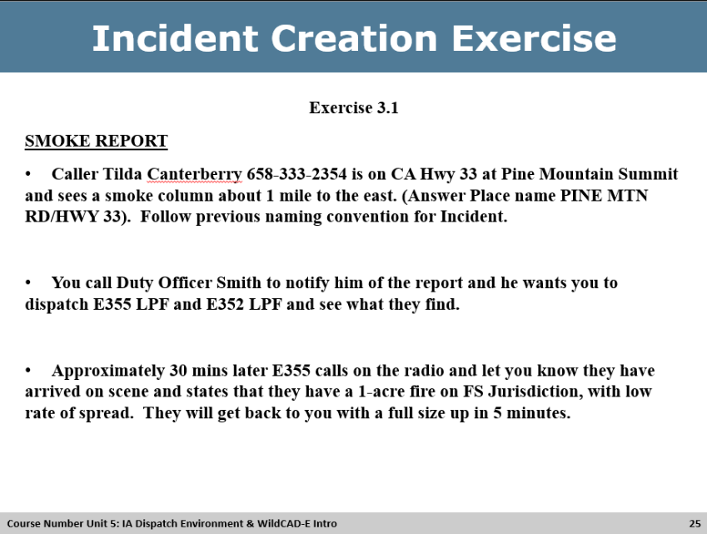

Activity – Handout 3

Exercise 3.1 Incident Creation – Smoke Report
Activity
Materials: Utilize Information on slide, handout and WildCAD-E Training platform.
Length: 20 min. (20 min. review slide/handout & perform exercise)
Purpose: The purpose of this activity is to provide students the opportunity to use the WildCAD-E program to learn and utilize fields in the system to create an incident.
Directions: Each student should review the handout and create a new incident utilizing the skills they learned in Handouts 1 & 2. There are 3 parts to this exercise, the smoke report, size up and follow up. The slides can be on the screen for reference, but they should use the handout to create and finalize the incident. Students should be able to independently create, enter and maintain incident information.
Instructor: Students should be able to create and enter information into an incident, using the correct tabs and fields.
Activity Debrief Questions: Review the answers at the end, to ensure that the students arrived at the correct answer. Coaches can review the student’s incidents real time before they move on to the next part of the exercise for correct action, using answer key. Optional *Instructor can have the students .pdf the incident and email to the coaches for review. The coaches can review and go over areas of improvement with students later.
Instructor and Coaches should review with answer key.

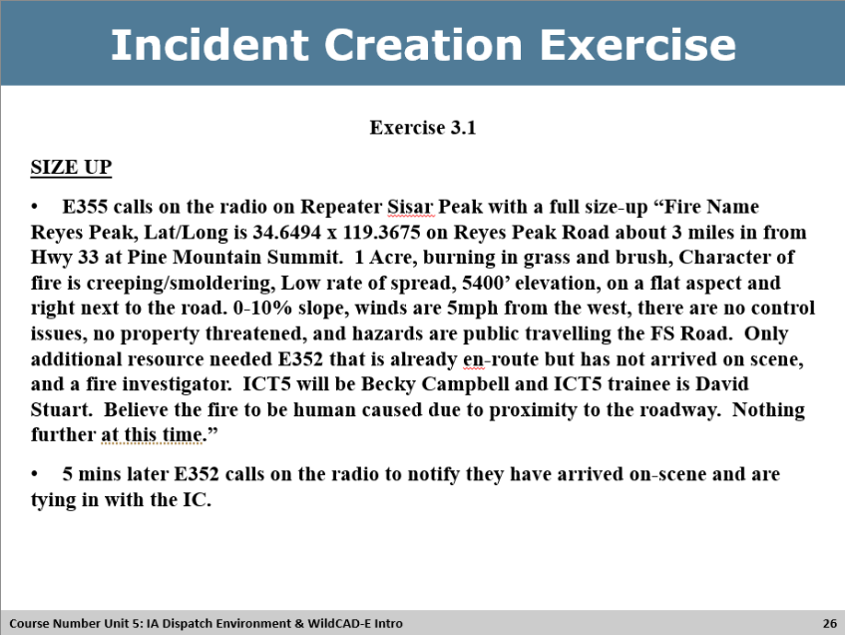
Activity – Handout 3

Exercise 3.1 Incident Creation – Size Up
Activity
Materials: Utilize Information on slide, handout and WildCAD-E Training platform.
Length: All part of the same exercise
Purpose: The purpose of this activity is to provide students the opportunity to use the WildCAD-E program to learn and utilize fields in the system to create an incident.
Directions: Each student should review the handout and create a new incident utilizing the skills they learned in Handouts 1 & 2. There are 3 parts to this exercise, the smoke report, size up and follow up. The slides can be on the screen for reference, but they should use the handout to create and finalize the incident. Students should be able to independently create, enter and maintain incident information.
Instructor: Students should be able to create and enter information into an incident, using the correct tabs and fields.
Activity Debrief Questions: Review the answers at the end, to ensure that the students arrived at the correct answer. Coaches can review the student’s incidents real time before they move on to the next part of the exercise for correct action, using answer key. Optional *Instructor can have the students .pdf the incident and email to the coaches for review. The coaches can review and go over areas of improvement with students later.
Instructor and Coaches should review with answer key.

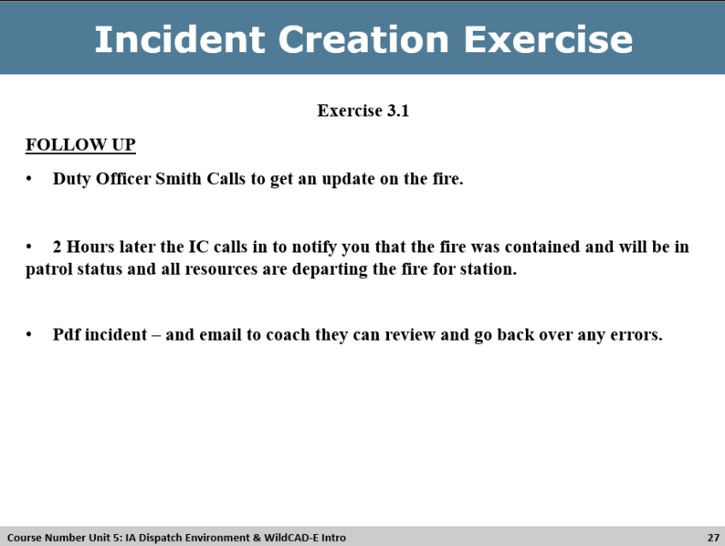
Activity – Handout 3

Exercise 3.1 Incident Creation – Follow Up
Activity
Materials: Utilize Information on slide, handout and WildCAD-E Training platform.
Length: All part of the same exercise
Purpose: The purpose of this activity is to provide students the opportunity to use the WildCAD-E program to learn and utilize fields in the system to create an incident.
Directions: Each student should review the handout and create a new incident utilizing the skills they learned in Handouts 1 & 2. There are 3 parts to this exercise, the smoke report, size up and follow up. The slides can be on the screen for reference, but they should use the handout to create and finalize the incident. Students should be able to independently create, enter and maintain incident information.
Instructor: Students should be able to create and enter information into an incident, using the correct tabs and fields.
Activity Debrief Questions: Review the answers at the end, to ensure that the students arrived at the correct answer. Coaches can review the student’s incidents real time before they move on to the next part of the exercise for correct action, using answer key. Optional *Instructor can have the students .pdf the incident and email to the coaches for review. The coaches can review and go over areas of improvement with students later.
Instructor and Coaches should review with answer key.

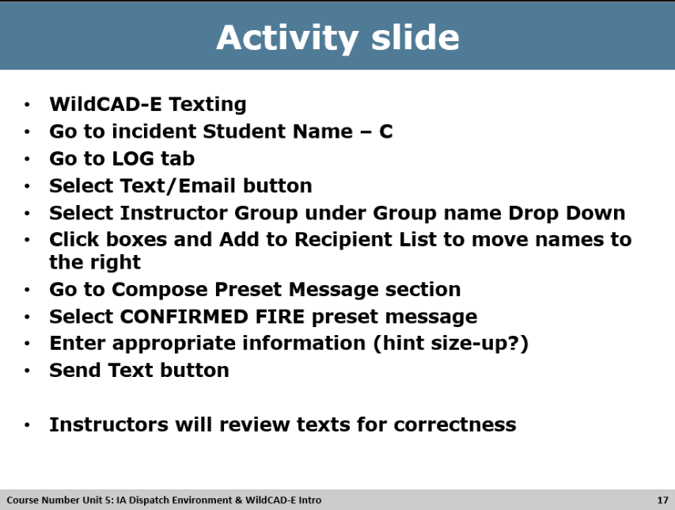

Activity – Texting functionality, part 1
Activity
<WildCAD-E Texting>
Materials: Utilize Information on slide, WildCAD-E Training platform.
Length: 15 min. (5 min. review slide and LOG tab, 5 min. activity, 5 min. debrief)
Purpose: The purpose of this activity is to provide students the opportunity to use the WildCAD-E program to utilize texting feature for incidents.
Directions: Each student should review information for texts on the slide and the size up documented in their incident log, and the activity provides an overview sending out texts for incidents in WildCAD-E utilizing the individual WILDCAD-E training platform to perform the exercises. Should done individually. The last exercise named Student name – C will be the incident used for the activity.
*Note to instructor – Need to Edit Baseline Instructional course session WildCAD-E for CALPCC Text/Email Addresses table & Text/Email Addresses Groups. These tables should be blank, you will need to add individual instructors’ numbers and then build and add all to the Instructor Group table.
Edit Text Preset message to the following fields: Jurisdiction, Location, INC#, Name, Est Size, ROS, Fuels, IC, leave map link. All others should be removed.
Instructor: Explain this is a preset text message, please discuss with students how text messages sent from the incident are documented in the incident log, and who they were sent to. Discuss that some centers may or may not use preset messages, and the importance preset messages and efficiency.
Activity Debrief Questions: Review the answers at the end, to ensure that the students arrived at the correct answer. Texts should have been sent to the pre-identified instructors added to the Text/Email Instructor group.
Answers: Should be like below
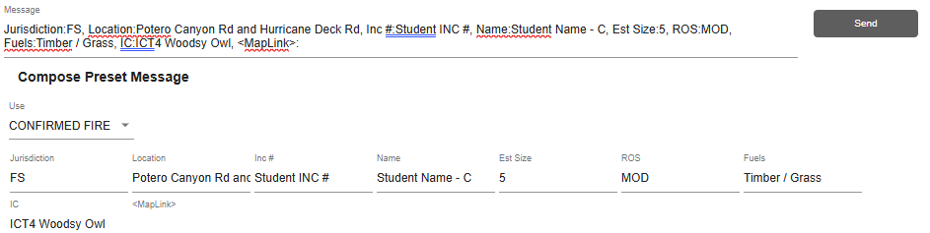
Coach Directions: The coaches can assist students during the exercise.

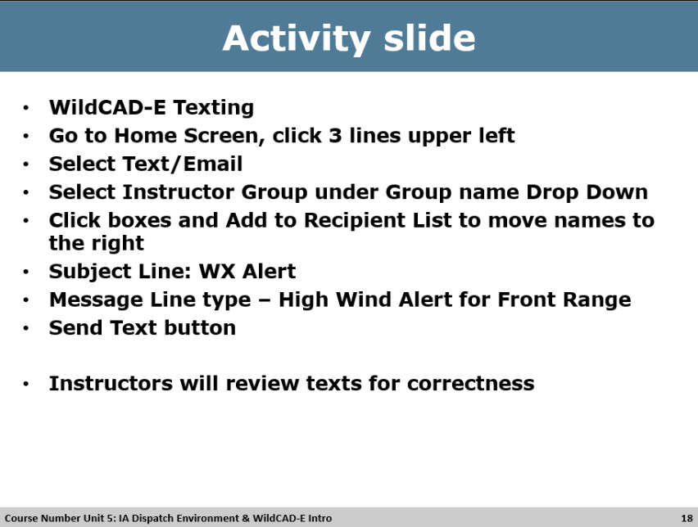

Activity – Texting functionality, part 2
Activity
<WildCAD-E Texting>
Materials: Utilize Information on slide, WildCAD-E Training platform.
Length: 15 min. (5 min. review slide and WildCAD menu, 5 min. activity, 5 min. debrief)
Purpose: The purpose of this activity is to provide students the opportunity to use the WildCAD-E program to utilize texting feature for general information sharing.
Directions: Each student should review information for texts on the slide and the size up documented in their incident log, and the activity provides an overview sending out texts for general information sharing in WildCAD-E utilizing the individual WILDCAD-E training platform to perform the exercises. Should done individually.
*Note to instructor – Need to Edit Baseline Instructional course session WildCAD-E for CALPCC Text/Email Addresses table & Text/Email Addresses Groups. These tables should be blank, you will need to add individual instructors’ numbers and then build and add all to the Instructor Group table.
Instructor: Explain this is a free type text message, please discuss with students how text messages sent from the menu are documented in the daily log, and who they were sent to.
Activity Debrief Questions: Review the answers at the end, to ensure that the students arrived at the correct answer. Texts should have been sent to the pre-identified instructors added to the Text/Email Instructor group.
Answers: Should be like below
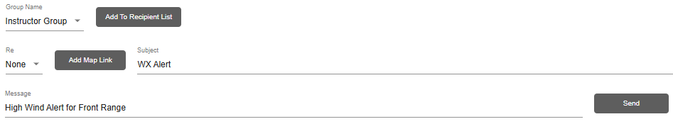
Coach Directions: The coaches can assist students during the exercise.

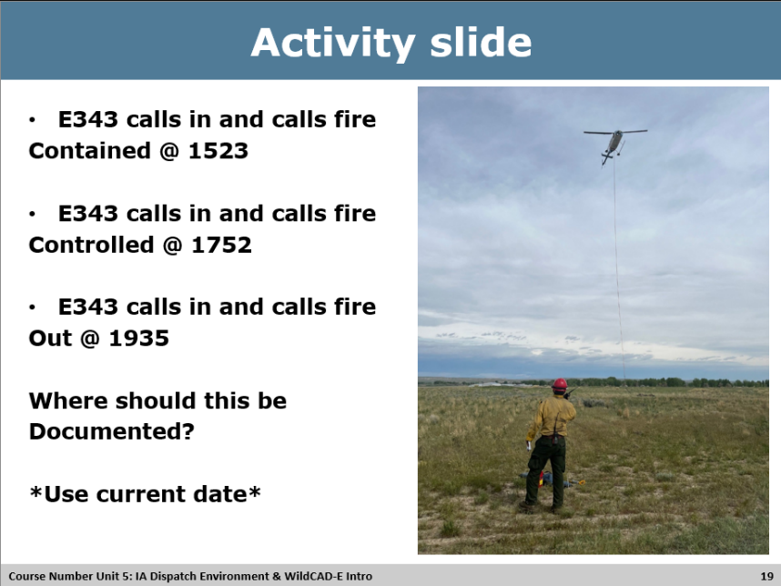

Activity – Contain, Controlled & Out
Activity
<WildCAD-E Fires Tab>
Materials: Utilize the dates and times on the slide, WildCAD-E Training platform.
Length: 15 min. (5 min. review slide and Fires tab, 5 min. activity, 5 min. debrief)
Purpose: The purpose of this activity is to provide students the opportunity to use the WildCAD-E program to utilize the fires tab to contain, control and enter out times for incidents.
Directions: Each student should review times and dates on the slide, and the activity provides an overview of closing the incident out in WildCAD-E utilizing the individual WILDCAD-E training platform to perform the exercises. Can be done individually or as a group, instructor discretion. The last exercise named Student name – C will be the incident used for the activity.
Activity Debrief Questions: Review the answers at the end, to ensure that the students arrived at the correct answer.
Answers:
- Fires Tab, enter correct times into contain, controlled and out fields. Make sure the 3 entries are also documented in the incident log tab as well. Discuss why this piece is critical and not to just enter on the fires tab.
Coach Directions: The coaches can assist students during the exercises.

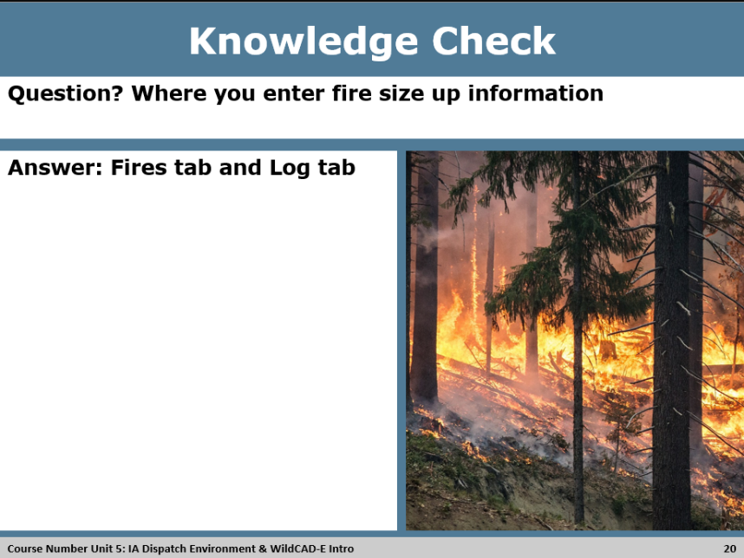

Knowledge Check
Knowledge Check Discussion
DO:
- Review the Knowledge Check Question with the participants.

- Call on a participant(s) to provide an answer to the question.

- Display the answer on the PowerPoint slide.

ASK: The question on the slide.< Where you enter fire size up information?>

Answer: Refer to answer on slide < Fires tab and Log tab>

Instructor: Explain the importance of why it is critical to enter the size up in the incident log tab, so that it is time and date stamped.

What questions do you have? Respond to questions as needed.
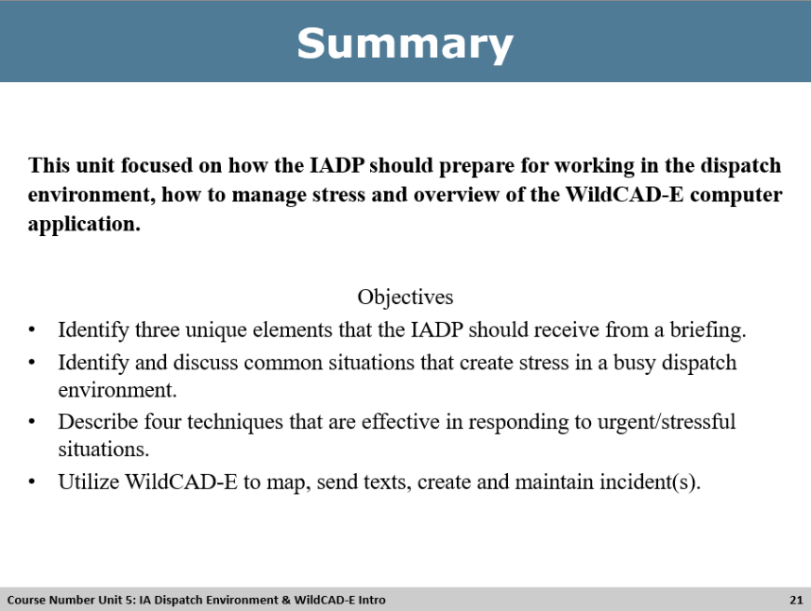

Unit Summary
Summary
DO:
- Refer to the PowerPoint Summary slide.
- Review with participants the learning outcomes of the unit.

